Little Tew Church
A short Family service,
For grown-ups and children.
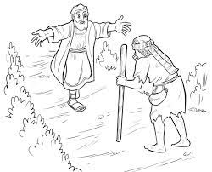

Sunday 26th June 10am
All welcome,
refreshments afterwards.

